Le verbe être

être ça veut dire: _____________

Je ____________ ________________________
Tu ____________ ________________________
Il ____________ ________________________
Elle ____________ ________________________
- When talking about yourself, you use _____________________.

Ex. __________________________________________

- When you are talking to a friend, you use ________________________.

Ex. __________________________________________

- When talking about a boy or a man, you use ________________________.
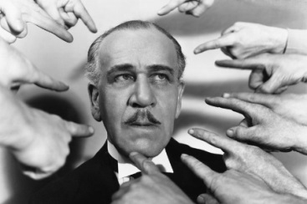

Ex. __________________________________________

- When you are talking about a female, you use ________________________.

Ex. __________________________________________
- When talking about things, you use ________________________________________
Because all things have ______________________________

Exemples:

Le livre? ________________________________

La règle? ________________________________

- La negation (negation) When you want to make a sentence say the opposite, or negative, you put ________________ around the verb! You make a verb sandwich.
Exemple:

Je suis grand. _______________________

ATTENTION! When the NE comes before another E, it changes to ___________

Exemples:

Tu es patient. _______________________

Il est petit. _______________________

Elle est blonde. _______________________

